can we use any listeners in angular to Set up an interval for checking expiry of tokens in Angular.

it is possible to use intervals in Angular to periodically check a token's expiration time, and RxJS provides a robust and idiomatic way to achieve this.
Using RxJS interval:
RxJS interval operator is a preferred method for creating periodic tasks in Angular applications due to its observable-based nature, which integrates well with Angular's reactive programming paradigm.
Here's an example of how to set up an interval to check token expiration using RxJS interval in an Angular service:

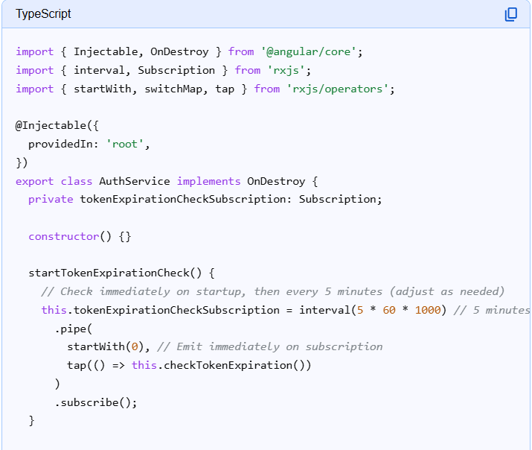

Explanation:
- interval(period):
Creates an observable that emits sequential numbers every period milliseconds.
- startWith(0):
Ensures an immediate check when the subscription starts, without waiting for the initial interval.
- tap(() => this.checkTokenExpiration()):
Performs the token expiration check as a side effect for each emission from the interval.
- subscribe():
Initiates the observable and starts the interval.
- ngOnDestroy():
It is crucial to unsubscribe from the interval in ngOnDestroy to prevent memory leaks when the service or component is destroyed.

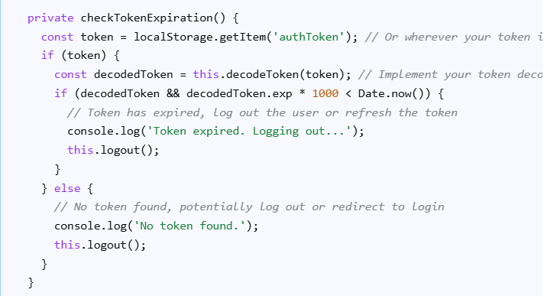
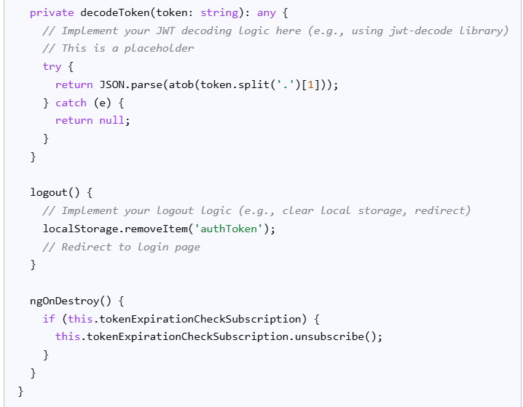

Alternative (less recommended): setInterval
While setInterval can also be used, it is generally less favored in modern Angular development due to its imperative nature and potential for issues with change detection if not handled carefully (e.g., using NgZone.runOutsideAngular). The RxJS interval approach offers better integration with Angular's change detection and lifecycle hooks.

Code version
import { Injectable, OnDestroy } from '@angular/core';
import { interval, Subscription } from 'rxjs';
import { startWith, switchMap, tap } from 'rxjs/operators';

@Injectable({
providedIn: 'root',
})
export class AuthService implements OnDestroy {
private tokenExpirationCheckSubscription: Subscription;

constructor() {}

startTokenExpirationCheck() {
// Check immediately on startup, then every 5 minutes (adjust as needed)
this.tokenExpirationCheckSubscription = interval(5 * 60 * 1000) // 5 minutes
.pipe(
startWith(0), // Emit immediately on subscription
tap(() => this.checkTokenExpiration())
)
.subscribe();
}

private checkTokenExpiration() {
const token = localStorage.getItem('authToken'); // Or wherever your token is stored
if (token) {
const decodedToken = this.decodeToken(token); // Implement your token decoding logic
if (decodedToken && decodedToken.exp * 1000 < Date.now()) {
// Token has expired, log out the user or refresh the token
console.log('Token expired. Logging out...');
this.logout();
}
} else {
// No token found, potentially log out or redirect to login
console.log('No token found.');
this.logout();
}
}

private decodeToken(token: string): any {
// Implement your JWT decoding logic here (e.g., using jwt-decode library)
// This is a placeholder
try {
return JSON.parse(atob(token.split('.')[1]));
} catch (e) {
return null;
}
}

logout() {
// Implement your logout logic (e.g., clear local storage, redirect)
localStorage.removeItem('authToken');
// Redirect to login page
}

ngOnDestroy() {
if (this.tokenExpirationCheckSubscription) {
this.tokenExpirationCheckSubscription.unsubscribe();
}
}
}

To learn about reactive programming with RXJS simple example:
https://medium.com/@louistrinh/using-rxjs-for-repeated-tasks-in-angular-fbb66b8bf1fa

